Auxiliary Data Acquisition Unit

GT Off-Road Racing | Data Acquisition

Evelyn Craven

06/16/21

Table of Contents

1.0 Overview 2

1.1 Introduction 2

1.2 Point of Contact 2

2.0 Hardware Reference 3

2.1 Pinout 3

*2.2 Parts*4

3.0 Software Theory of Operation 5

4.0 Suggestions 6

5.0 Revision History 7

# 1.0 Overview

## 1.1 Introduction

The Auxiliary Data Acquisition Unit (Aux DAQ) is a PCB inside a 3D-printed casing that is attached to the car. The board has connection points for various forms of sensor input (SPI, I2C, UART, digital, and analog and digital inputs at both 3.3V and 5V), which are used for testing and data collection purposes.

## 1.2 Point of Contact

Evelyn Craven (evelynmc314@gmail.com)

# 2.0 Hardware Reference

## 2.1 Board

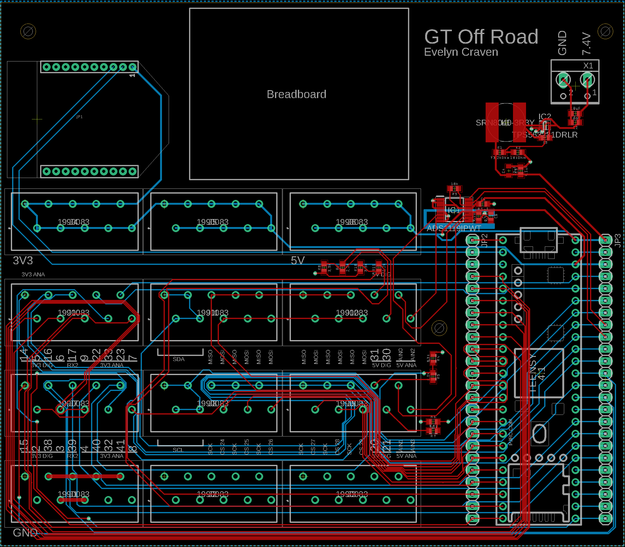*Figure 1: Aux DAQ EAGLE Board*

On the EAGLE board, the various sensor inputs are labeled in block terminals on the left side of the board. In the top row, the first two terminals are 3.3 V power outputs and the third is a 5V power output. The middle two rows contain the sensor inputs, which are divided into blocks. For example, the first three pins on the second and third rows are 3.3V digital inputs, the fourth pins on those rows are UART inputs, and so on according to the labels. The bottom row is ground.

## 2.2 Parts

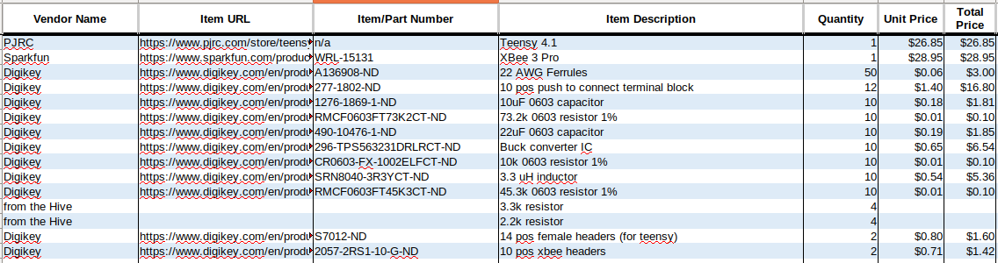

*Table 1: BOM*

# 3.0 Software Theory of Operation

The code for the Aux DAQ Unit uses the SDWrite library to read data from each sensor.

# 4.0 Suggestions

## 4.1 Terminal Blocks

The terminal blocks used for the sensor inputs were difficult to use with ferrules. The push connection (as opposed to screw terminals) would have made putting wires in and out much easier, but they may need to be a larger size to accommodate ferrules. They were also fairly expensive.

## 4.2 Positioning of Components

The current layout of the board seemed to work fine, but if the connectors should intuitively be placed elsewhere, that could be accommodated in a redesign.

## 4.3 Breadboard

I’m not sure if the breadboard was used.

# 5.0 Revision History

06/16/2021 – Created document